P5 NPOI Capstone

Final Report

Bradley Kingsley
Dustin Haines
Trung Son Nguyen

Fall 2022 – Spring 2023
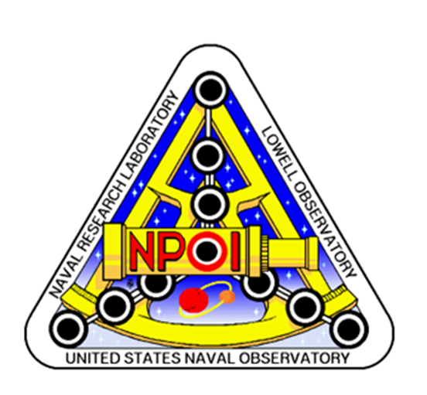

Project Sponsor: Jim Clark
Instructor: Armin Eilaghi

DISCLAIMER
This report was prepared by students as part of a university course requirement. While considerable effort has been put into the project, it is not the work of licensed engineers and has not undergone the extensive verification that is common in the profession. The information, data, conclusions, and content of this report should not be relied on or utilized without thorough, independent testing and verification. University faculty members may have been associated with this project as advisors, sponsors, or course instructors, but as such they are not responsible for the accuracy of results or conclusions.

EXECUTIVE SUMMARY
Many components require maintenance or repair, especially the heart of NPOI, the Fast Delay Lines (FDL). The Snoots contain custom vacuum windows allowing stellar light to enter and exit of the FDL tanks. The FDL tank Seal Plates also allow the metrology beam into and out of the tank which allows for highly accurate measurements of cart positions, on the order of a nanometer. These inner tank components from time to time must be repaired. This entails the front and/or rear seal plates to be moved/stowed and FDL tank inners worked on in an appropriate clean environment. Then all components must be reinstalled easily. Over the course of Fast Delay Line (FDL) use, there is need for periodic maintenance within the vacuum tanks confining the FDL Carts. On the front of the FDL’s there are seal plates which capture snoots to relay the light in and out of the inner room. These seal plates and snoots use many features which take long lengths of time to disassemble and assemble. This issue is apparent on the front and rear of the tanks, although the rear seal plates do not have optical pass throughs. Reducing the use of large tools (gantry crane) and quantity of technicians needed to complete this task would be most beneficial to the Opto-Mechanical Group (OMG) at NPOI. The goal of this project is to streamline these procedures to make it faster and easier to perform maintenance on the FDL’s.

There are two main aspects of the design, the front and rear seal plates, along with the snoot fixture. This plate will be light weighted but cutting out a significant portion of the unused space, to adhere to the customer need of weight. The polycarbonate windows will have an O-ring to help seal, along with a hat to fix it to the plate. The snoots will be welded onto the plate itself, while the metrology windows will be held in place by a hat that will fasten it to the plate. The rear seal plate uses the same size aluminum plate (2-in thick, 22-in diameter) and functions very similar to the front seal plate. The key difference is that the rear seal plate must have two sight ports, that allow the customer to view inside the FDL. Like the front seal plate, this plate will also be light weighted to meet the constraint of the customer. The snoot fixture involved a simpler implementation than the seal plates. The function of the snoot fixture is to stabilize the snoots, as well as provide the ability for slight adjustments. This will be done by fixing a solid base to the existing frame at NPOI, while having a plate that the snoots will be fixed to, that will be able to move in all the required directions. The finalized CAD models are included in section 5. The simulations run in solid works proved that our design functions and adheres to the constraints of the client.

ACKNOWLEDGEMENTS
Professor and Client: Jim Clark
The Naval Research Laboratory
The Navy Precision Optical Interferometer

ME486C Professor: Armin Eilaghi

TABLE OF CONTENTS
Contents
DISCLAIMER 1
EXECUTIVE SUMMARY 3
ACKNOWLEDGEMENTS 4
TABLE OF CONTENTS 5
1 BACKGROUND 1
1.1 Introduction 1
1.2 Project Description 1
2 REQUIREMENTS 3
2.1 Customer Requirements (CRs) 3
2.2 Engineering Requirements (ERs) 3
2.3 Functional Decomposition 4
2.3.1 Black Box Model 4
2.3.2 Functional Model/Work-Process Diagram/Hierarchical Task Analysis 5
2.4 House of Quality (HoQ) 6
2.5 Standards, Codes, and Regulations 6
3 DESIGN SPACE RESEARCH 7
3.1 Literature Review 7
3.1.1 Student 1 (Bradley Ian Kingsley) 7
3.1.2 Student 2 (Dustin John Haines) 8
3.1.3 Student 3 (Trung Son Nguyen) 9
3.2 Benchmarking 9
3.2.1 System Level Benchmarking 9
3.2.1.1 Existing Design #2: Aluminum Vacuum Chamber 11
3.2.1.2 Existing Design #3: Sealing aluminum chamber 11
3.2.2 Subsystem Level Benchmarking 12
3.2.2.1 Subsystem #1: Seal Plates 12
3.2.2.1.1 Existing Design #1: Descriptive Title 12
3.2.2.1.2 Existing Design #2: Demountable Seals: Metal 12
3.2.2.1.3 Existing Design #3: Demountable Seals: Elastomers 12
3.2.2.2 Subsystem #2: Sight Port 12
3.2.2.2.1 Existing Design #1: Caf2 Vacuum Viewpoint 13
3.2.2.2.2 Existing Design #2: Sapphire Viewpoint 13
3.2.2.2.3 Existing Design #3: KF Flange Tempered Glass Viewpoint 13
3.2.3 Subsystem #3: Snoots and Snoot Fixture/Adjuster 14
3.2.3.1.1 Existing Design #1: Horse Sleeve Seal 14
3.2.3.1.2 Existing Design #2: Clamp connection 14
3.2.3.1.3 Existing Design #3: Metal Bellows 15
4 CONCEPT GENERATION 16
4.1 Full System Concepts 16
4.1.1 Full System Design #1: Magnesium, Rubber Sleeve Seal, Acrylic Sight Port. (M.R.A.) 16
4.1.2 Full System Design #2: Aluminum, O-Ring Seal, Polycarbonate Sight Port. (A.O.P.) 16
4.1.3 Full System Design #3: Steel, Hose Sleeve Seal, Tempered Glass. (S.H.T.) 16
4.2 Subsystem Concepts 16
4.2.1 Subsystem #1: Front Seal Plate 17
4.2.1.1 1.1.1.1 Design #1: Preexisting Plate 17
4.2.1.2 1.1.1.2 Design #2: Custom Mount 17
4.2.2 Subsystem #2: Sight Port 17
4.2.2.1 Design #1: 3 Sight Port 17
4.2.2.2 Design #2: 2 Sight Port 17
4.2.2.3 Design #3: Window Sight Port 18
4.2.3 Subsystem #3: Snoots and Snoot Fixture/Adjuster 18
4.2.3.1 Design #1: Screw Adjuster 18
4.2.3.2 Design #2: Hose-Like-Endings 18
4.2.3.3 Design #3: Spring Adjuster 18
4.2.3.4 Design #4: 4-Section Snoot 19
4.2.3.5 Design #5: 3-Section Snoot 19
5 DESIGN SELECTED – First Semester 21
5.1 Technical Selection Criteria 21
5.2 Rationale for Design Selection 21
6 Project Management – Second Semester 23
6.1 Gantt Chart 23
6.2 Purchasing Plan 23
6.3 Manufacturing Plan 24
6.4 Major Changes Applied during Second Semester and Justifications – as needed 24
7 Final Hardware 25
7.1 Final Hardware Images and Descriptions 25
7.2 Design Changes in Second Semester 27
7.2.1 Design Iteration 1: COVER CHANGES FROM METAL TO BLACKOUT FABRIC WITH VELCRO 27
7.3 Challenges Bested 28
8 Testing 29
8.1 Testing Plan 29
8.2 Testing Results 29
9 RISK ANALYSIS AND MITIGATION 31
9.1 Potential Failures Identified First Semester 31
9.2 Potential Failures Identified This Semester 31
9.3 Risk Mitigation 32
10 LOOKING FORWARD 33
10.1 Future Testing Procedures 33
10.2 Future Iterations 33
11 CONCLUSIONS 35
11.1 Reflection 35
11.2 Resource Wishlist 35
11.3 Project Applicability 36
12 REFERENCES 36
13 APPENDICES 38
13.1 Appendix A: FMEA 38
13.2 Appendix B: BOM and Budget 39
Contents

BACKGROUND

Introduction
The Navy Precision Optical Interferometer (NPOI) is a large astronomical observation station, created by the Navy Research Lab. The goal of NPOI is to observe faint, double, and triple stars, using the siderostat stations and use of the delay and combining lab. The 2022-2023 NPOI capstone will be based on the Fast Delay Lines (FDL), specifically the seal plates and snoots. The project includes designing rear seal plates, front seal plates with snoots, a snoot adjustment fixture, and a snoot split design. The team will design a simple rear seal plate to hold the moderate FDL vacuum, as well as integrate sight ports in the seal plate for easy inspection. The front seal plate will seal vacuum, hold the stellar and metrology snoots, and integrate view ports for easy inspection. The seal plates will also need to have a weight of 35 lbs. or less. The snoots must have an inner room fixture, allowing adjustment (pitch and yaw), as well as holding the last section of the snoot split design. The inner room section of the snoot will be stationary when accessing the front of the FDL’s. The split snoot design is a sectional tube which will be easily able to have sections removed for access in removing the front seal plate. The combination of these four objectives is to create a FDL seal plate system which one technician can assemble and disassemble with ease.

The sponsor of this project Jim Clark is interested in completing this design project because of maintenance requirements of the FDL’s, along with the need for keeping the interferometer on sky nightly. The maintenance requirements for the FDL’s are ribbon cable replacement, voice coil tuning, piezo tuning, bearing replacement, and leaf spring replacement. These maintenance items must be repaired in a quick and efficient time frame, allowing the seal plates to be less than 35 lbs., allowing any single technician the option to vent and disassemble an FDL individually. As well as removing the use of the gantry crane completely. This allows the small staff at NPOI to work on issues in parallel, instead of one at a time. Removing the gantry crane from the FDL room will also remedy the issue of tripping hazards within the FDL room, due to the gantry crane tracks. The use of the sectional snoot allows for ease of disassembly of the snoots and removes a lengthy step once fully reassembled. Alignment of the snoots will be removed using sectional snoots, this allows for the inner room section of snoot to be fixed, allowing the team to keep alignments of snoots through disassembly and reassembly. The remedy of these issues will allow the client and stakeholders to more easily maintain the FDL’s, remove safety issues in the FDL room, and reduce the number of needed alignments during FDL maintenance.

Project Description
The following is the project description given by the Navy Precision Optical Interferometer and client Jim Clark.

The central goal of all astronomical observation is to better understand our universe and how it works. Earth and our solar system are just one possible astrophysical arrangement, so what we can learn by looking around our own neighborhood is limited. By observing the billions of other systems out there, we can develop a better understanding of what other arrangements are possible, how they might have formed, and what the implications are for potential future off-earth explorations.

Just as when you view the world with just one eye, there are limitations to viewing celestial phenomena from a single point, i.e., a traditional telescope. Observation of many 2D features benefits from combining multiple views of the target from points that are spread out spatially, a technique called interferometry. For example, the centroid of binary systems changes as one star orbits its partner, and it is the centroid of the binary system that a single telescope measures to generate a catalog of stellar positions; other applications include star-spots (which have yet to be seen!), accretion discs (as the stars spin and toss out matter of different temperature and mass), star rotations (what is the spin rate and orientation of polar axis?) and other interesting science that single telescopes simply cannot measure; we may eventually be able to use nulling interferometry for exoplanet detection.

The Navy Precision Optical Interferometer (NPOI), an astronomical long-baseline optical interferometer, has been in operation on Anderson Mesa, just outside Flagstaff, Arizona, since 1994. This facility was funded by the Naval Research Lab and the U.S. Naval Observatory and built on Forest Service land supplied using a Special Use Permit (SUP), held by Lowell Observatory. An aerial view of the site, shown in Figure 1, illustrates the general shape and layout of the 2.2-meter to 437-meter baseline array. The NPOI has a unique capacity for detecting and determining motions and orbits of binary systems. Many regional partners collaborate with NPOI to take advantage of its unique capabilities, including Northern Arizona University, New Mexico Tech, Seabrook Engineering, Tennessee State University, and Lowell Observatory.

The NPOI collects and combines light from up to six apertures simultaneously to form a high spatial resolution synthetic aperture. The wavelength range of operation is currently in the visible spectrum, 400 nanometers to 800 nanometers, and will soon include infrared wavelengths. Reconfigurability of the array generates baselines from 2.2-meters to 437-meters, and the light collected at each station is transported as a 12.7 centimeters beam through evacuated pipes to a beam combiner. Reconfiguration of the array is analogous to a zoom lens on a Digital Single-Lens Reflex (DSLR) camera.

Many components require maintenance or repair, especially the heart of NPOI, the Fast Delay Lines (FDL). The Fast Delay Lines (Figure 2), housed by vacuum tanks are used to zero the path difference, within 10’s of nanometers, from each siderostat to allow for the beams to be combined in phase. At the front of these tanks, snoots (Figure 4) are used to equalize air distances through the entire optical path. Snoots allow stellar light into the FDL’s and back out after respective reflections. The Snoots contain custom vacuum windows allowing stellar light to enter and exit of the FDL tanks. The FDL tank Seal Plates also allow the metrology beam into and out of the tank which allows for highly accurate measurements of cart positions, on the order of a nanometer. These inner tank components from time to time must be repaired. This entails the front and/or rear seal plates to be moved/stowed and FDL tank inners worked on in an appropriate clean environment. Then all components must be reinstalled easily. Presently, an overhead gantry crane and multiple technicians are required for disassembly of the FDL seal plates and snoots.

Over the course of Fast Delay Line (FDL) use, there is need for periodic maintenance within the vacuum tanks confining the FDL Carts. On the front of the FDL’s there are seal plates which capture snoots to relay the light in and out of the inner room. Figure 3 shows the snoots exiting the delay line tanks. Figure 4 shows the snoots as seen from the inner room. These seal plates and snoots use many features which take long lengths of time to disassemble and assemble. This issue is apparent on the front and rear of the tanks, although the rear seal plates do not have optical pass throughs. Reducing the use of large tools (gantry crane) and quantity of technicians needed to complete this task would be most beneficial to the Opto-Mechanical Group (OMG) at NPOI.

The project deliverable has been updated due to partner transitions and inability to access the purchased hardware. The updated deliverable is a 35% scale model, which is 3D printed, that will act as the proof of concept for the overall design. This prototype allows the team to test the system at smaller scale for functionality and ergonomics of the system.

REQUIREMENTS

Customer Requirements (CRs)
In pursuit of designing a new FDL system for NPOI, many customer requirements were needed and defined by the customer. The customer requirements are listed below with weights in parenthesis.
- Lightweight (4)
- User/Technician Friendly (4)
- Seals to Vacuum (5)
- Stable Alignment (5)
- Small Deformation (3)
- Adjustable Frame (4)
- Sight Ports (2)
- Within a $9500 Budget (5)
- Durable and Robust Design (5)
- Reliable Operation (5)
- Safe to Operate in All Vacuum States (5)
The first customer requirement is for the design to be lightweight, specifically aimed at the seal plates. This requirement was issued for obtaining a seal plate which could be lifted by one person, by hand. Essentially removing the need for a gantry crane when removing the seal plates on the front and back of the FDL tanks. A weight of 4 was given due to the high desire for this plate to be lightweight. User/Technician friendly is a requirement given to ease the workload of the OMG, specifically reduce time and alignments needed for any maintenance of the FDL’s. A weight of 4 was given to this requirement because we need to ease the difficulty of the system, but this is not the main goal. Seals to Vacuum is necessary for this design due to the need to hold a moderate vacuum for extended periods of time. The weight of 5 was given because the plates must seal vacuum, there is no room for error in this requirement. When designing the seal plate, small deflection is desired, specifically we want the plate to not be visibly deformed. This is required for safety of the seal plate and comfort of use of the plate, this was weighted a 3. The weight of 3 was given because if we accomplish the other goals and this requirement is not fully complete, it may be slightly neglected by the client. The snoot adjustable frame was required because the design needs a fixture which can hold the snoots in alignment over time. A weight of 4 was given because this is a specific sub-section that must be accomplished. Sight ports were required by the customer because the need for internal inspection while the system is under vacuum, is needed. A weight of 2 was given to this because they are not absolutely needed by the client, but it would be a good addition. The budget for this project is $9500, this must be strictly used, with no additional funding, thus the weight of 5. The requirement for durable, robust, and reliable operation of the design is given a weight of 5, this is because the design must handle many assembly cycles, movements of pieces and possible issues. The system must also be totally safe to operate at all vacuum states (1mTorr and ATM), the weight of 5 was given because the system must be safe to be around at any state. The definitions of our customer requirements will help produce the engineering requirements with specified units associated.

Engineering Requirements (ERs)
To define more specific parameters of the design, using the customer requirements, engineering requirements were created for quantifying the customer requirements. Each engineering requirement is paired with a unit to indicate how the requirement will be measured. Below if the engineering requirements for the NPOI Capstone.
- Less than 35 lbs.
- Disassembly in less than 1 hour
- Seals tanks at ATM (760 Torr) and Vacuum (1mTorr)
- X and Y Adjustment of ±0.5in
- Deformation less than 0.010”
- Drift less than 0.001 in/month
- At least 2 sight ports
The engineering requirement of less than 35 lbs. are specified for the front and rear seal plates. This requirement ensures that a single technician can remove the seal plate by hand, removing the use of the gantry crane. Disassembly within less than one hour is specified to ease the workload of the technicians, allowing for more tanks to be opened within a single day. The seal plates must also seal the FDL tanks in ATM and in vacuum, this specifies that the tanks will hold the inner contents under any condition. The snoots must be adjustable to ±0.5 in due to the need for fine alignments of the snoots if any beam is clipped on any hardware. The seal plates must have a deformation of less than 0.010” because the plates must be strong enough to hold the external atmospheric pressure, and if larger deflections are happening fatigue might be worth investigating. The drift of the snoots must be less than 0.001 in/month because alignments of the snoots should not have to happen often, other than when they are bumped, or a stable temperature issue arises. The use of 2 or more sight ports within the seal plates allows for easy viewing on the FDL internals for issues or mechanical snags. These ports allow for the tanks to not be vented in order to view the FDL inners, saving time and work for the OMG. Reliability and durability of the system are tied to deformation and sealing to vacuum, because the reliability to seal to vacuum is based on if the plates can seal at ATM and vacuum. Along with the need for the design to be durable, the deformation must be small to not induce fatigue into the design. These engineering requirements will direct the team on how the design will be geometrically built and defined for the customer needs.

Functional Decomposition

Black Box Model
A black box model is a simple diagram which shows how a system has specific input and output, but does not show the inner workings of how this system will work. Specifically what signal, energy, and material will be input and output from the system. Figure 1: Black Box Model, shows the model for the P5 NPOI Capstone.
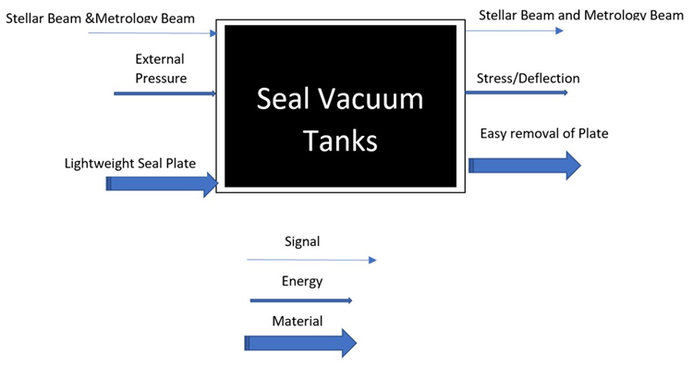
Fig 1 - Black Box Model
The inputs for the system are defined as stellar/metrology beams, external pressure, and lightweight seal plate. The beams being input are the beams which must pass through the seal plate, through a vacuum window, allowing the light to be reflected at the FDL cart. External pressure is also the input because external pressure will put force on the seal plate, specifically strain energy. The seal plate being lightweight is also an input, this is because the plate must be light to be able to be installed by hand. The signal output is the metrology/stellar beams, these beams act as the signal for the system because without these there would be no interferometry. The output of energy is stress and deflection of the seal plate, the input pressure has a direct cause for stress and deflection. The output for material is the seal plate must be easy to remove, allowing the material to be moved easily.

This black box model allows the team to simplify the system to only needed components and shows the team how the system works. This model shows all the absolutely needed components in the system, specifically the seal plate with windows allowing signal through and how the seal plate reacts with nature and humans. This model also shows the team how the system works in a very general sense, Allowing for concepts to be generated that easily incorporate the needed inputs and outputs, ensuring the needed features for functionality are included in each design.

Functional Model/Work-Process Diagram/Hierarchical Task Analysis
The functional model is used to show the specific functions of a specified part or design. Specifically creating a flow diagram of how the part will work with more specifics, that are nt shown in the black box model. The team created a functional model of the front seal plate to analyze, being what functions does the seal plate have and what is specifically needed for the design. The front seal plate function model is presented in figure 2.
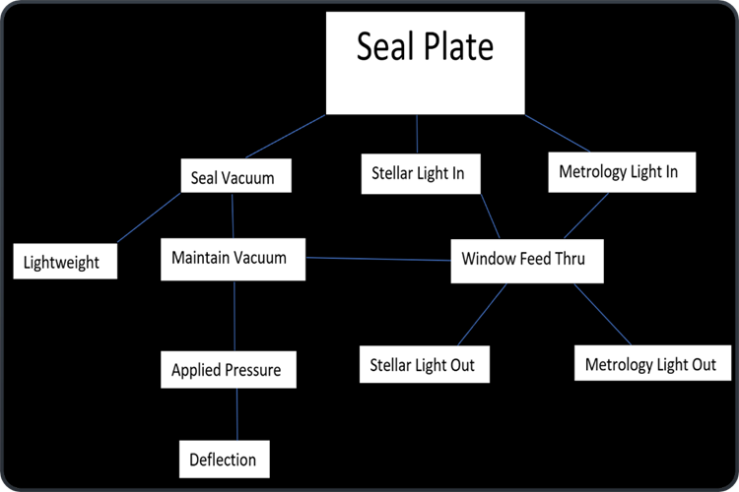
Fig 2 - Functional Decomposition Model
The functional model shown for the front seal plate shows 3 main functions with a few sub functions that are essential for success of the design. The seal plate will allow stellar and metrology light in and out, using vacuum windows for each input or output beam. This specifies the plate must have transparent windows sealed to the plate which can allow laser and stellar light to pass in and out of the FDL tank. The need for the plate to seal to vacuum is essential to success of the design, this is tied with lightweight and maintains vacuum. Although the seal plate will be lightweight (>35 lbs.), it must maintain a vacuum without issue, even if most of the plate weight is removed strategically for weight reduction. The applied pressure and deflection also correlated with maintaining a vacuum, when the seal plate gets deformed by pressure, the specified O-ring geometry might change. This shows the need for advanced finite element analysis (FEA) to ensure the seals do not leak when the plate deforms. The decomposition models give the group a simple chart to follow to ensure all the needed geometry and pass through will be included and will work properly, even with changes from ATM to vacuum.

House of Quality (HoQ)
The house or quality (HoQ) was used by the team to relate the requirements and weights to what specific will be most important/correlated to the overall design. The HoQ is shown in figure 2. Customer and engineering requirements were inserted, and weights were associated with each to define what portions are most important to least important. The team used the HoQ in the concept generation and evaluation stages to specify if the concepts will be accomplishing these requirements or if they fall short. Three separate systems were reviewed for the HoQ, and the customer was asked to complete the survey on the systems. The client stated since the system is so specific to the site, these separate systems relate in a very small way, yet the survey was completed to the best ability. This allows the team to view other systems that may have a small amount of relation that could be used in the design. The HoQ was beneficial when generating concepts and evaluating the concepts.
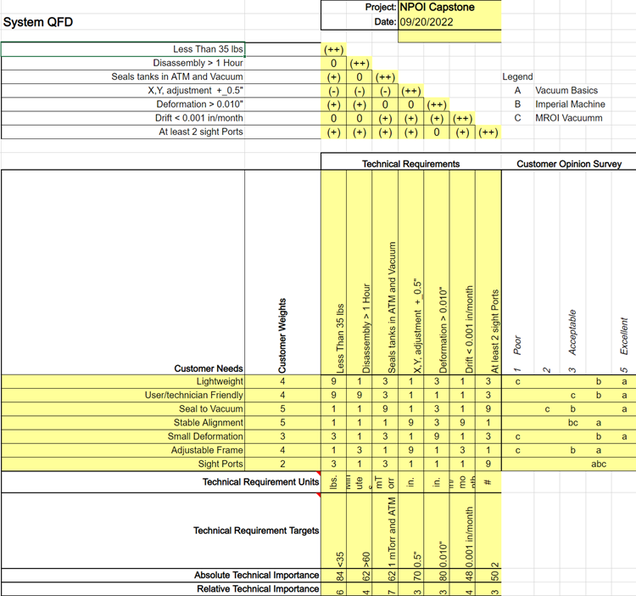
Fig. 3 - House of Quality

Standards, Codes, and Regulations
The team must adhere to specific codes within the fabrication and engineering world in order to be able to specify properties, callout welds for vacuum application, and create drawings which are in common layouts. Shown in table 1, the codes which must be adhered to and looked up for proper use. ASTM B209-14 is a material standard that relies on the manufacturer to specify that the code is upheld in the process. This code allows for the team to indicate material properties that will be used for finite element analysis, allowing a more accurate simulation. The ASME Y14 standard allows the team to create drawings with various forms of dimension so the part will be made to our design. The standard allows for specific callout for geometric dimensioning, allowing the team to more precisely dimension the shop drawings. The AWS D17.1 code allows for the team to callout the specific welds needed for vacuum application, without worry of failure of the vacuum seal. This specification ensures that the welds designed will conform to vacuum/aerospace standards, allowing the welds to be used for the specific vacuum application.

Table I: Standards of Practice as Applied to this Project
Standard Number or Code | Title of Standard | How it applies to Project
ASTM B209-14 | Standard Specifications for Aluminum and Aluminum Alloy Sheet and Plate | The material received for the Seal Plates conforms to this standard in all respects. Allows the Team to apply material properties for analysis without worry of severe material imperfections.
ASME Y14 | Y14 Standards | Drawing packages are similar in nature in the direction of dimensions and layout. This allows the team to use GD&T and basic tolerancing to create part drawings effectively.
AWS D17.1 | AWS D17.1/D17.1M:2017-AMD1 | The welding specification for fusion welding for aerospace applications. This related the welding process that may be used to attach the snoots to the front seal plate. The welds must conform to this standard due to the vacuum application.

DESIGN SPACE RESEARCH

Literature Review

Student 1 (Bradley Ian Kingsley)
This student would be in charge of finding alternative ways to reduce the weight of the existing seal plates. Now, the seal plates at NPOI weighed over a hundred pounds, which made the assembly/disassembly processes difficult as a gantry crane was required in order to support the processes. Due to that problem, the goal was to reduce the weight of the seal plates down to thirty-five pounds or less so that one person could assemble/disassemble the seal plates out of FDL tank without any need of gantry crane.
Light Weight Design Without Compromising Design for Manufacturing [16]
This source provided different methods to light weight the design, using different materials or changing the moment of inertia of the design to reduce weight. Because the seal plates and snoots had a fixed dimension, the team could only make changes based on the existing objects. By calculating where most of the stress applied to the seal plates, the team would change the design by removing the unnecessary parts with pattern on the seal plates to reduce its total weight.
How to Evaluate Materials – Properties to Consider [17]
There were many factors to consider when choosing the materials, not only the weight. From the article, there were about fourteen sections that could affect the outcome of the materials. For this project specifically, the team would focus on density, ductility and hardness than other properties. The density would directly affect the weight of the materials used while the hardness of the materials showed the deformation resistance when operating under vacuum conditions.
Material and Process Design for Lightweight Structures [18]
The book provided reports from the author about the method of reducing the damage in the bending methodology. Processing advanced steels could reduce the weight of the material and the bending effect. There were various methods that been used in the book to achieve the goal of reducing the weight of the material and structure, which would benefit the team for our project.
Aluminum supplier [12]
The existing seal plates were made of aluminum. Based on that experience, the team decided to use aluminum as the material for new seal plates. This aluminum supplier provided aluminum objects with different shapes and even customized extrusion which was that the team was looking for. The company’s aluminum process service could be useful when the team made the final product for the Spring term.
Interview with the client, Jim Clark
Jim Clark discussed with the team the main problems and difficulties when using the gantry crane during working hours. Jim Clark also suggested that the team could use magnesium for the seal plates due to its low density compared to aluminum, however, after careful consideration, the team decided not to use magnesium due to the cost and flammability.

Student 2 (Dustin John Haines)
This student would oversee sight ports and alignment of the whole system. The sight ports were asked by Jim Clark to check out everything during operating procedure. This student also studied the dimensions of the existing designs through the CAD drawings at NPOI.
Vacuum Viewport [23]
This website provided different types of sight ports, which also included the strength and spectrality. Based on the conditions of stellar and metrology beams, the team could choose the right sight ports to install in the seal plates.
Interview with Jim Clark
After a meeting with Jim Clark about the place of sight ports, the team learnt the particulars place to install the sight ports. Moreover, the team would customize the pattern on the seal plates to match with the client wants, the mushroom pattern.
NPOI CAD drawings
At NPOI, the team got in touch with the previous CAD drawings. By achieving the actual CAD drawings, this student could experiment with the best place to install the sight ports when under atmospheric pressure.
Sight Glasses [27]
This company provided various sight ports glasses and windows. The team could use this site as a reference when ordering a sight port to install on the seal plates.
Sealing options for vacuum chamber [20]
Although this source was about sealing options for vacuum chamber, the company themselves showed a great product which included a large amount of sight ports on the vacuum chamber. The team could contact the company when needed to do a custom sight port on the vacuum seal plates.

Student 3 (Trung Son Nguyen)
This student is responsible for the connection and the flexibility for the snoot. Based on the team’ designs, each part of the snoot could be connected by several types of connectors. In this literature review, the student would cover distinct types of connectors as well as how to make the snoot more flexible.
Flexible Pipe Bellow [24]
This website contains diverse types of connections, from quick clamps, flange to pipe bellows. This company had great experience in making and supplying various connection parts as well as connection types. The team could use this information as a reference when doing the design for the snoot.
Metal bellows [25]
The bellows was a great connection due to flexibility. The website explained the function of the bellows as a flexibility component that could prevent leak as well as seal effectively. The metal bellows would be a great choice for the design of the snoot.
Interview with Jim Clark
Jim Clark had some specific requirements for the snoots. Firstly, the number of the snoots would increase from two to four for both way in and out of the stellar and metrology beams light. Secondly, the snoots would be easily removed for maintenance without showing displacement of the stellar and metrology beams light. With that information, the student decided that the snoots would be divided into four parts, with two parts connected to the inner room and front seal plates, one part would be removed independently, and the final part was the bellows.
The Importance of Choosing the Correct Material for Vacuum O-Rings and Vacuum Seals [1]
This source presented information about the benefit of choosing the right materials for the O-rings and vacuum seals. The deformation rates of varied materials could affect the quality of sealing, hence affecting the entire system. By knowing the
Fitting and Flanges [7]
The Ideal Vacuum company sold a variety of equipment and products for vacuum products. This included different types of fittings and flanges, which used to hold our snoot parts together. This company could be used to supply our required fitting parts.

Benchmarking

System Level Benchmarking
Existing Design #1: NPOI FDL vacuum tank
The existing design of snoots, front and back seal plates came directly from NPOI. Because the design would be based on the NPOI version, the team would take the design as main source to work on. The designs had all necessary dimensions on the seal plates to reduce the weight.
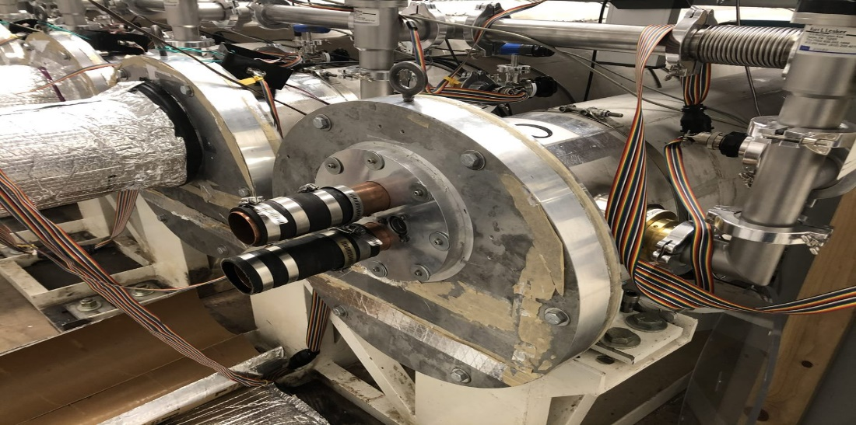
Fig. 3 - Front seal plate
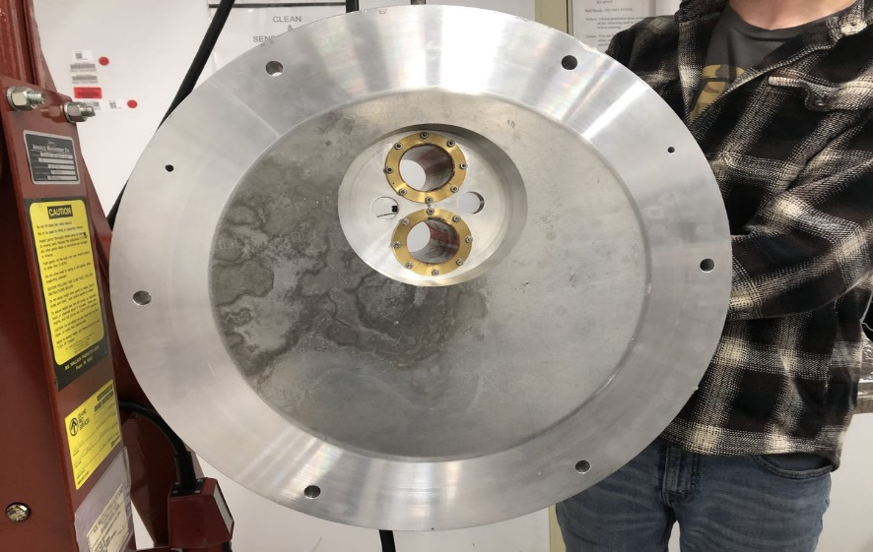
Fig. 4 - Back view of front seal plates.

Existing Design #2: Aluminum Vacuum Chamber
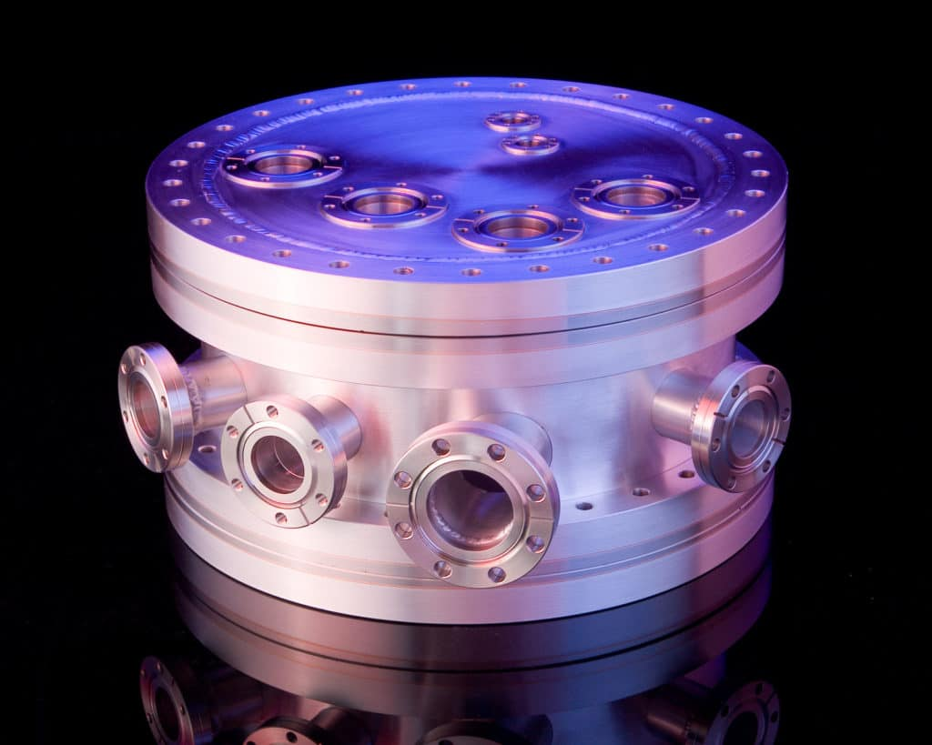
Fig. 5 - Aluminum vacuum chamber
This design was a vacuum chamber with various sigh ports to view inside during the process. Jim Clark, the client, wanted the team to add sigh ports on both front and back seal plates to observe the process and make sure that everything operated correctly. This design would help the team to learn and design the sight port that could withstand the vacuum force and had minimum deformation.[20]

Existing Design #3: Sealing aluminum chamber
This design showed similarity to the shape of the actual design, but smaller in scale. The seal of this vacuum chamber was thinner compared to the actual design but still could seal the chamber tank with the support of three clamps. The team could use the design to lightweight the seal plates by reducing the thickness of seal plate and adding clamps to tight the seal plates with the tank [21].
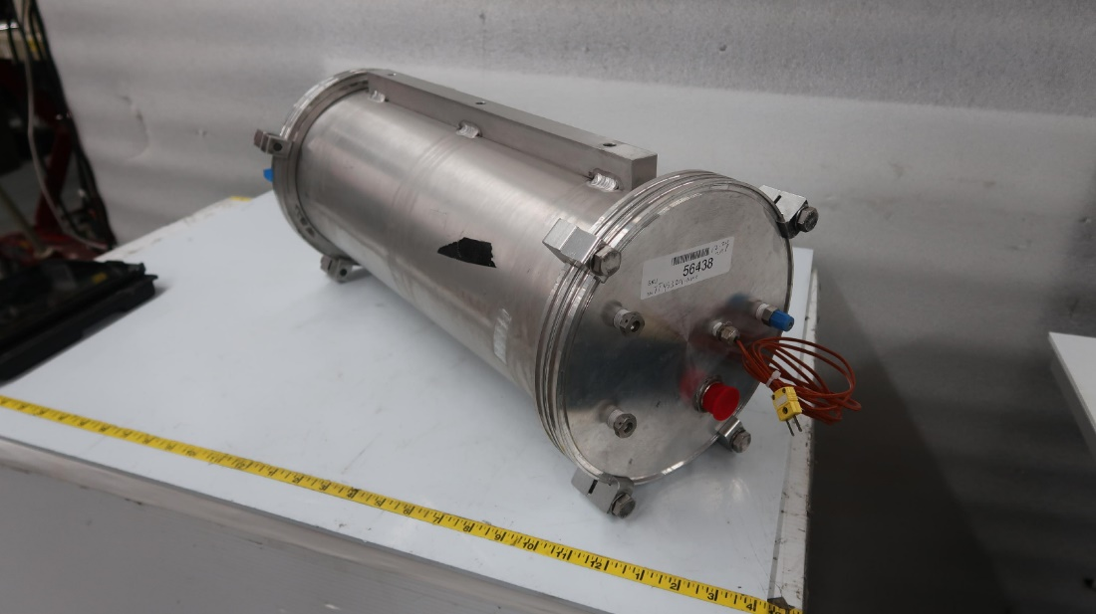
Fig. 6 - Sealing Aluminum Chamber

Subsystem Level Benchmarking

Subsystem #1: Seal Plates
The seal plates had an important role in this project. From the functional decomposition model, the seal plates had a series of requirements, which included to be lightweight, being able to withstand vacuum force and having a small deflection rate. The seal plates could directly affect the lab result if they did not function as intended so the seal plates were one of the main focuses on this project.

Existing Design #1: Descriptive Title
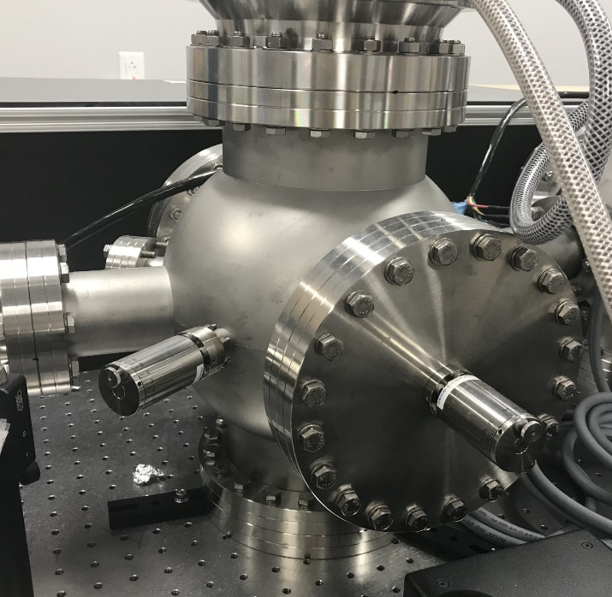
Fig. 7 - High levels of vacuum tank
The seal plates showed excellent tightness and reduced the deformation rate, however, as the team wanted a lightweight seal plate, this design was for reference only [22].

Existing Design #2: Demountable Seals: Metal
The metal seals were used in high vacuum levels. Common metal seals include the knife-edge, wire seal and metal jacketed spring seals. Metal jacketed spring seals consist of a helical spring enclosed within a ductile outer metal jacket which yields under compression to create a seal [26]. This seal was a reference for the team to use in the project.

Existing Design #3: Demountable Seals: Elastomers
The common seal used on vacuum chambers was a flanged or door joint sealed with an elastomer gasket. This type of seal also included an O-ring that would compress and fit inside the vacuum chamber, which would seal the tank perfectly [26]. This design suggested the team of a seal plate that used O-ring.

Subsystem #2: Sight Port
From the functional decomposition model, the seal plates needed window see through for the stellar and metrology beams light to go through. This subsystem investigated various existing sight ports to install on the seal plates. This subsystem was important because the stellar and metrology beams light was the main purpose of the FDL tank, so the sigh port needed to be clear and able to work under vacuum conditions.

Existing Design #1: Caf2 Vacuum Viewpoint
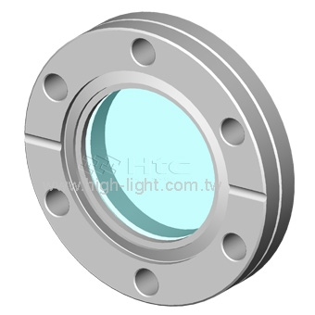
Fig. 8 - Caf2 Vacuum Viewpoint
The Caf2 lenses had high transmission from 250nm to 7μm. This window manufactured from vacuum UV grade calcium fluoride could be used in our project [23].

Existing Design #2: Sapphire Viewpoint
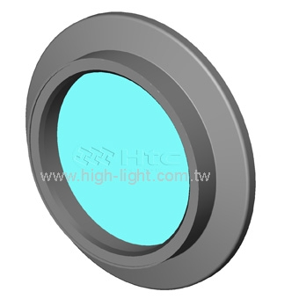
Fig. 9 - Sapphire Viewpoint
The sapphire viewport provided excellent optical quality, with the transmission of UV up to eighty percent. This viewport could be used under pressure of 10^(-8) Torr with temperature range from -100ºC to 450ºC. The team could use this sight port for the project [23].

Existing Design #3: KF Flange Tempered Glass Viewpoint
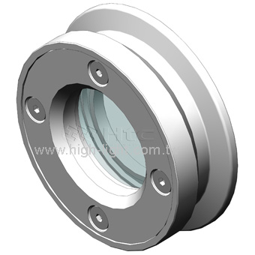
Fig. 10 - KF Flange Glass Viewpoint
This KF Flange Glass sigh port included an O-ring to have tight seal with the plate surface. This sigh port had high vacuum applications. The team could use this sigh port for the stellar and metrology beams [23].

Subsystem #3: Snoots and Snoot Fixture/Adjuster
This subsystem was important because the snoots delivered stellar and metrology beams. From the black box model, the stellar and metrology beams went inside the vacuum tank through one snoot and came back in another snoot. That was why by focusing and snoot and snoot adjuster, the team would reduce the time required for snoot maintained as well as reduce the error of stellar and metrology beams displaced from the wanted place.

Existing Design #1: Horse Sleeve Seal
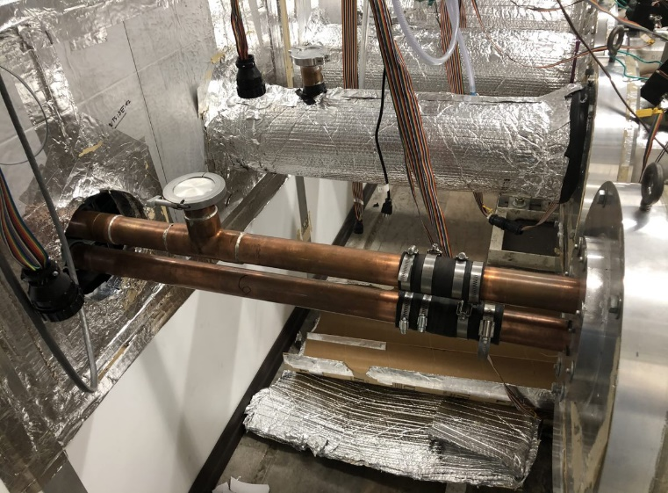
Fig. 11 - Exposed Snoot
This existing subsystem contained a part of the snoot connected to the seal plate and another part went inside the dark room. The two parts were connected by a horse sleeve seal. This design provided an additional method that the team could use to connect different parts of the snoot together.

Existing Design #2: Clamp connection
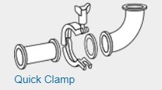
Fig. 12 - Clamp connection
This design was about having two parts of the snoot connected by an O-ring and sealed with a quick clamp. This design inspired our team to use this as final snoot connection due to the low price of the clamp and the ability to seal the air and light. [24]

Existing Design #3: Metal Bellows
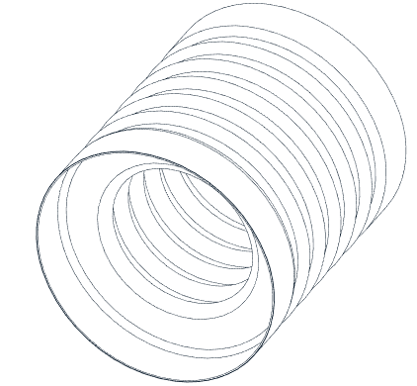
Fig. 13 - Metal Bellows
Metal bellows provided flexibility to the snoot. By using the bellows, the team could have the snoot in the dark room fixed and connected to the metal bellows while the outside snoot could easily connect to the dark room snoot through the metal bellows. With the flexibility from the metal bellows, the team did not need to remove the dark room snoot. [25]

CONCEPT GENERATION

Full System Concepts
The full system concepts primarily vary in three categories: material, seal type, and sight port material. The overall design, such as thickness, mounting type, sight port location, etc. are heavily restricted by the customer, therefore there is not much visual difference between each concept.

Full System Design #1: Magnesium, Rubber Sleeve Seal, Acrylic Sight Port. (M.R.A.)
The M.R.A. design uses magnesium as the material for the seal plates, with a rubber sleeve seal and acrylic sight ports. Magnesium allows the team to easily achieve the weight constraint, although magnesium is flammable, making the machining of that material more difficult. The rubber sleeve seal provides a cheap and easily implemented way to keep a seal in the vacuum, but slightly less reliable than some of the other alternatives. Finally, acrylic is cheaper and allows clear viewing into the FDL’s but is prone to cracking and is weak.

Full System Design #2: Aluminum, O-Ring Seal, Polycarbonate Sight Port. (A.O.P.)
The A.O.P. design uses aluminum as the material for the seal plates, along with an O-ring seal, and polycarbonate sight ports. Aluminum is a cheap material that is easily machines, however it is weaker. The O-ring seal type is currently implanted with the existing seal plates making it easier to implement. The polycarbonate sight ports are lighter and stronger than the other alternatives, but do not offer as clear of a view.

Full System Design #3: Steel, Hose Sleeve Seal, Tempered Glass. (S.H.T.)
The S.H.T. design uses steel as the material for the seal plates, alongside a hose sleeve seal, and tempered glass sight ports. Steel is the strongest material considered, but is extremely heavy, meaning that substantial material would have to be cut out of the plate to reach our weight goal. The hose sleeve seal is like the rubber sleeve, but is slightly cheaper and more easily ordered, while being slightly weaker than the rubber sleeve. The tempered glass is extremely clear but is much more expensive than the other alternatives and heavy.
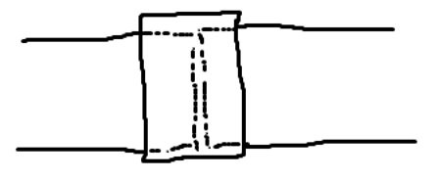
Fig. 15 – Hose Sleeve Seal

Subsystem Concepts
The overall design includes three subsystems; front seal plate, rear seal plate, and snoot/snoot adjustment configuration.

Subsystem #1: Front Seal Plate

1.1.1.1 Design #1: Preexisting Plate
This seal plate uses the preexisting snoot mount that the current seal plates use. The only difference between the old plates and this design are the material, and some light weighting. Using this Plate makes implementing our design much easier, but also restricts some of the functions that we need to design for.

1.1.1.2 Design #2: Custom Mount
This design will use a custom snoot mount that attaches to the front seal plate. This means that more will have to be spent to machine the new mount but will allow for new housing for the snoots. The new mounts will also be lighter.

Subsystem #2: Sight Port

Design #1: 3 Sight Port
This design uses three sight ports aligned along the top of the seal plate. This will allow for more visibility on the inside of the FDL, depending on the area of interest. Cutting more holes into the plate will make it lighter, but also weaker.
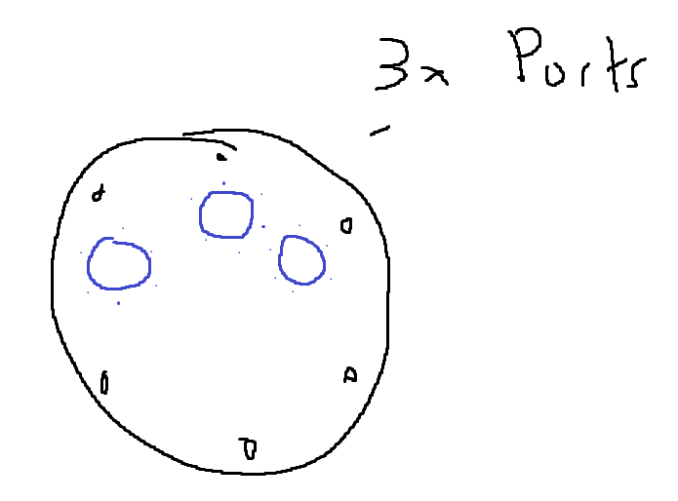
Fig. 16 - 3 Sight Port Configuration

Design #2: 2 Sight Port
This design, like the previous design, will have two sight ports located along the top of the seal plate. This is the bare minimum number of separated seal plates to allow for a light to be shone into the vacuum, along with a port for viewing. The decreased number of ports allows the plate to be stronger, but slightly heavier.
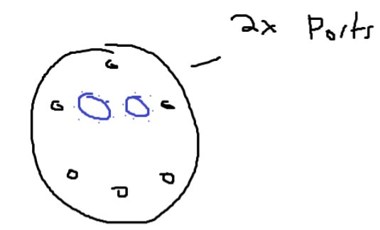
Fig. 17 - 2 Sight Port Configuration

Design #3: Window Sight Port
This design uses a singular, large sight port that curves around the plate. This option allows for the most visibility, but is extremely weak, and prone to deformation. This would jeopardize the strength of the seal plate.
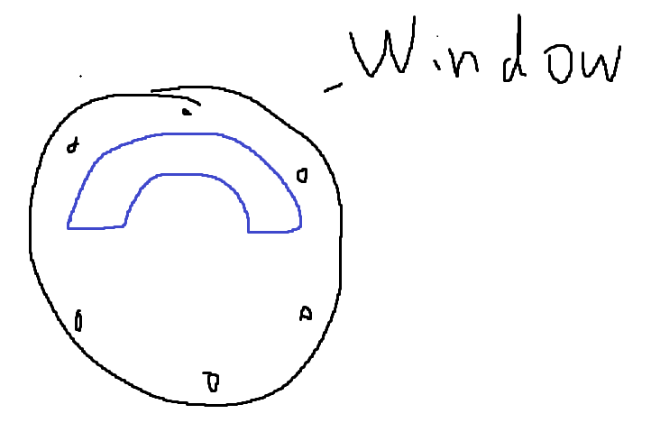
Fig. 18 - Window Sight Port Configuration

Subsystem #3: Snoots and Snoot Fixture/Adjuster

Design #1: Screw Adjuster
This design uses a screw mounted to a baseplate to move the snoots for alignment. This will be done by having the snoots covered in a metal housing connected to a screw on the bottom and side of the snoot. This design is cheap and easy to manufacture, but is not precise and not stable.
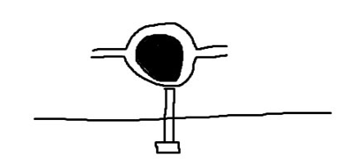
Fig. 18 - Screw Adjuster

Design #2: Hose-Like-Endings
This design uses a hose-like-material that is malleable that will be connected to a baseplate and the snoot. This will allow the snoot to move in every direction with little effort. While this design is cheap and easy to remove when maintenance is being performed, it is very weak.

Design #3: Spring Adjuster
This design uses a spring to mount the snoot. This is done by suspending the snoot via a spring connected to surrounding housing for the snoot that will be able to be fastened to varying heights and angles, along the side of the baseplate. This design will be easy to adjust, and will be strong, but is limited in the ranges of adjustment
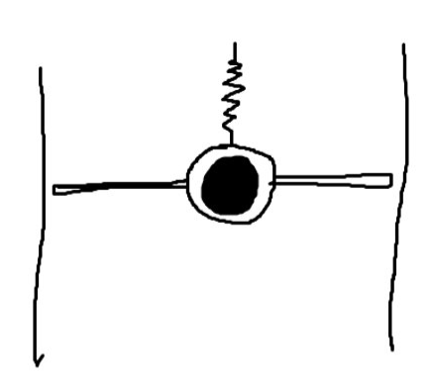
Fig. 19 - Spring Adjuster

Design #4: 4-Section Snoot
The 4-section snoot includes a snoot fixed to the wall, a bellow, the intermediate pipe, and the snoot attached to the front plate. The bellow is the flexible aspects of the design, allowing some movement in the snoot. This configuration allows for increased customization. The increased number of pieces in the assembly makes it less stable, however. The amount of seals and clamps increases as well, making the overall cost increase.
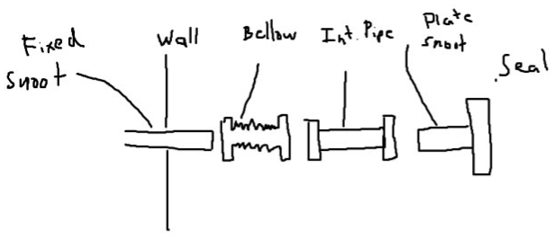
Fig. 20 - 4-Section Snoot Configuration

Design #5: 3-Section Snoot
The 3-section snoot is similar to the previous design, but it combines the fixed snoot in the wall with the bellow. This prevents some alterations during maintenance but will make the assembly more stable.

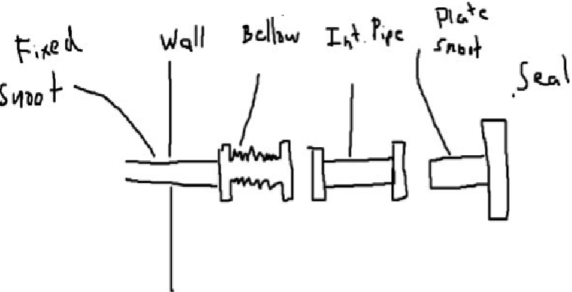
Fig. 21 - 3-Section Snoot Configuration

DESIGN SELECTED – First Semester
Section 5 represents the final decisions made after generating the initial designs. The designs are compared to one another as well as the customer needs and engineering requirements. Both the good and bad aspects of each design are analyzed and are rated based off those criteria. Included in this section is the Pugh and Decision Matrix for our projects design.

Technical Selection Criteria
While evaluating the previous designs, there were critical technical criteria that were used to evaluate each concept, which closely relate to the customer needs/engineering requirements. There exist two separate modes of evaluation, one for the seal plates, and one for the snoot/snoot mounts. For the seal plates, weight, price, strength, machinability, and visibility were the criteria. For the snoots, price, strength, and reliability were considered. Each aspect was directly compared to each other via a Pugh Chart to achieve a baseline evaluation. Each aspect of the design was evaluated (i.e., plate material, sight port material, etc.) and then the total values were summed up to achieve an overall score for each design. After further consideration, the same criteria were used in a decision matrix, in this case each element was given a weight, based on importance for the overall design.

Rationale for Design Selection
After using the methods previously described to evaluate designs, two stood out as the best plate designs; A.O.P. and M.R.A. All three full system concepts were first evaluated in the following Pugh Chart,

TABLE I - Pugh Chart for Full System Concepts
 | Option 1 | Option 2 | Option 3
Criteria | M.R.A. | A.O.P. | S.H.T.
Weight | +++ | + | --
Price | - | + | -
Strength | + | ++ | +++
Machinability | -- | ++ | 0
Visibility | + | + | ++
Total: | +2 | +7 | +2

After some elaboration, it was decided that the first two options would progress to the next stage of evaluation. Even though options 1 and 2 got the same score, the last option is not feasible for this project. The steel is much too heavy, and the tempered glass is not as strong or reliable as we want. The other designs are more likely to work. They will be further evaluated with criteria weights with a decision matrix. The snoot/snoot configurations will only be evaluated using a decision matrix as there are already few options. The following table shows the Decision Matrix for the 2-remaining full-system concepts;

TABLE II - Decision Matrix for Full System Concepts
 |  | Option 1 | Option 2
Criteria | Value Weight | M.R.A. | A.O.P.
Weight | 3 | +++ | +
Price | 2 | - | +
Strength | 3 | + | ++
Machinability | 1 | -- | ++
Visibility | 1 | + | +
 | Total: | +8 | +14

Weight and strength are the most valuable traits as specified by the client. Price is secondary, but still important as we have a strict budget. Machinability refers to how easy it would be for the team to machine the parts or how cheap it would be if it is outsourced. Visibility is how well the sight ports would let an operator see into the FDL. These were given the least weight because each of the issues of machining these parts are simple, and each of the chosen materials are clear, so regardless of the quality one will be able to see through the material. Each evaluation is simple. Magnesium is extremely light and expensive while aluminum is not as light but much cheaper. Both materials can handle the load, this can be shown through some SolidWorks evaluation of the models we have made already. Magnesium is flammable, making the machining of the part more intensive, while aluminum is easy to machine. Both acrylic and polycarbonate are see-through. The following table shows the decision matrix for the snoot designs.
TABLE III - Decision Matrix for Snoot Alignment
 |  | Option 1 | Option 2 | Option 3
Criteria | Value Weight | Screw | Hose-like-endings | Spring
Price | 1 | ++ | + | ++
Strength | 3 | - | + | 0
Accuracy | 3 | - | ++ | +
 | Total: | -4 | +10 | +5

All options will be cheap, so it was weighed the lowest, while strength and accuracy were weighted much higher. Each design must be able to hold up the metal snoots and be able to accommodate small alterations for alignment. The screw option is extremely cheap, but inversely is not strong or accurate. The hose like ending is cheap, but also provide decent strength. They allow for extremely minor adjustments as well. The spring is also cheap but is lacking in strength as the spring must be weak enough to freely move. Accuracy also suffers as there can only be so many orientations available.

As concluded above, the A.O.P. and hose-like-endings designs scored the best, so they are the designs that we will be designing in the future.

Project Management – Second Semester

Gantt Chart
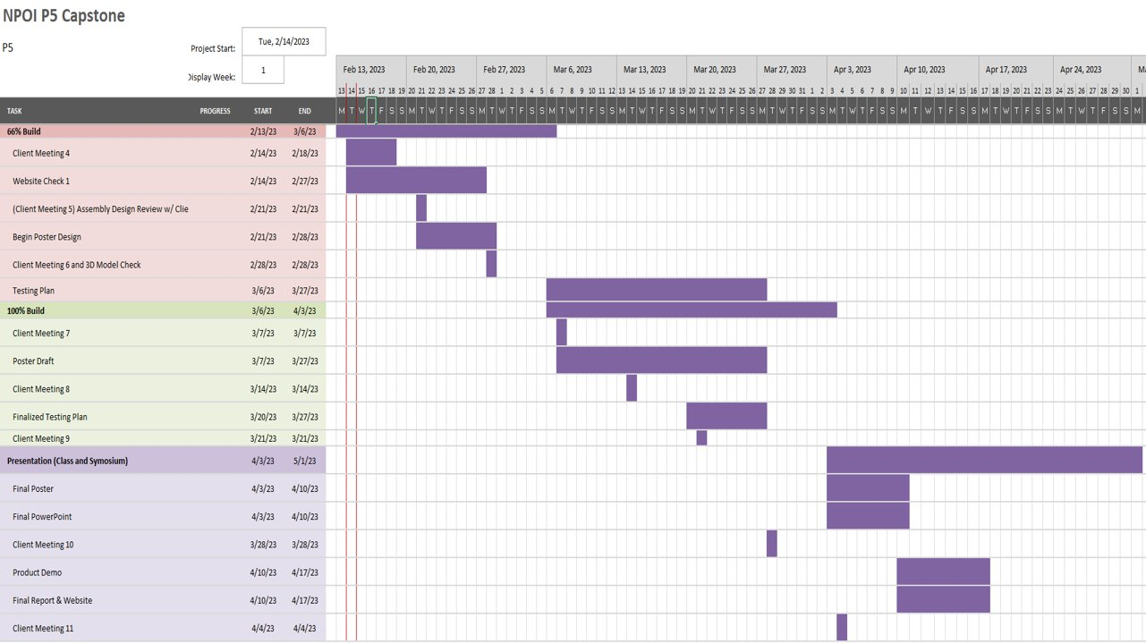
Fig. 22 – Spring 2023 Gantt chart.
The Gantt chart shows important events and the team’s working schedule for those events. Throughout the second semester, the team kept up with the schedule and did not fall behind. The team finished all the previous events such as 100% build and testing result. The next important event that the team needs to attend is the symposium.

Purchasing Plan

TABLE IV – Purchased Materials
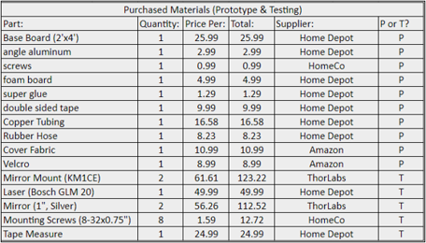
Due to partnership transition, the team could not use and modify any materials that were already bought and stayed inside the NPOI. Therefore, a 35% prototype had been made as a replacement. Table # shows all the materials that the team used to make the prototype, which could be easily obtained from Hompe Depot or Amazon.

Manufacturing Plan

TABLE V – Manufactured Parts
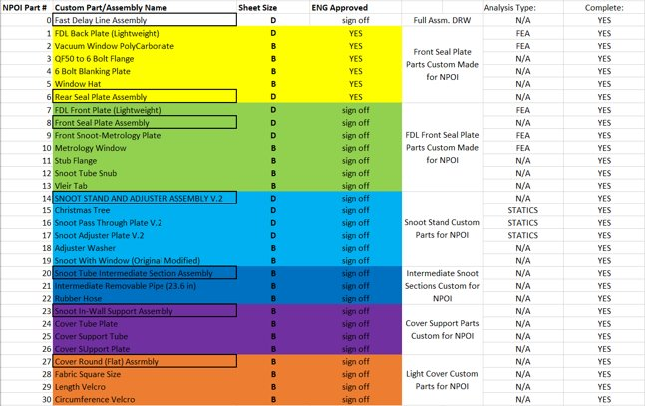
Table V provides the manufacturing process in second semester. The manufacturing process was about building different FDL systems from the 3-D printer. Moreover, a few utilities such as screws and bolts were included in the assemble process to show a full view of FDL systems.

Major Changes Applied during Second Semester and Justifications – as needed
Due to partnership transition, the team did not have access to the NPOI site. Therefore, all the progress that the team made during the first semester, including the attempt to build the system with aluminum, did not work anymore. To finish up the project, the team changed to build a 35% prototype of the system as a replacement. Because the system was 3D printing, there were a few technical changes compared to the initial plan, including purchasing and manufacturing plan. However, the team tried their best to complete the project as it was intended to be built in aluminum.

Final Hardware

Final Hardware Images and Descriptions
In this section, the team will present the final designs as well as explain their functionality.
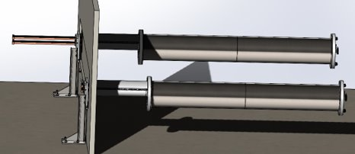
Fig. 23 – Completed design in SolidWorks.

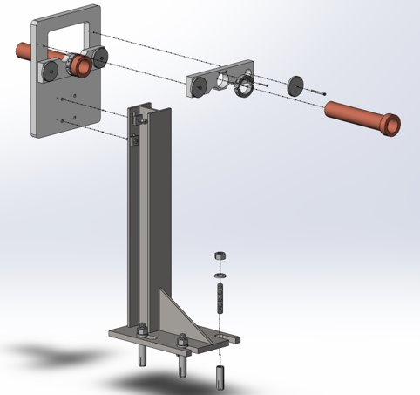
Fig. 24 – Snoot alignment system exploded view.

The final hardware consists of three parts: snoot adjustment, front and rear seal plates. The functionality of the snoot adjustment is to provide the adjustment function during the alignment of the snoot and stellar/metrology beams. With the new snoot adjustment, the time required to adjust the alignment will significantly be reduced. For the prototype, the snoot adjustment can be extended both horizontally and vertically about 0.125”. The new snoot system will be divided into 3 parts, with the two fixed snoot at the snoot adjustment plate and front seal plates while the middle snoot can be easily removed and assembled. By doing this, the time for assembling and disassembling the FDL system has been reduced to within an hour of work as well as get rid of the use of gantry crane.
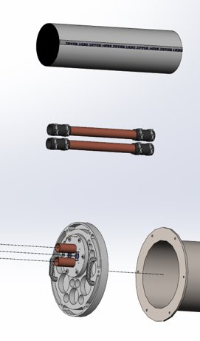
Fig. 25 – Removed snoot middle section.

Instead of using the old aluminum foil for light cover, which is inefficient for long-term use, the team redesigned the light cover for middle snoot by using blackout fabric. By attaching Velcro at the end parts of the fabric as well as the snoot plates, the light cover can be easily removed or put in within 10 minutes but still be able to block the light.
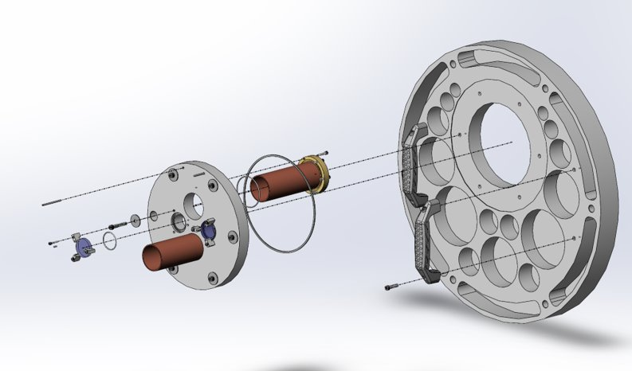
Fig. 26 – Front seal plate exploded view.

Alignment is an important factor in this project. Therefore, in the front seal plate, the team designed a snoot seal plate which could also be used to adjust the snoot alignment. In the original design, the front seal plate had to carry all the vacuum load, which resulted in heavy design. To reduce the weight of seal plate, the team decided that the new snoot stand would carry the vacuum force instead of front seal plate, which reduced the front seal plate to only 34 pounds. The seal plate also has new handles attached for carrying.
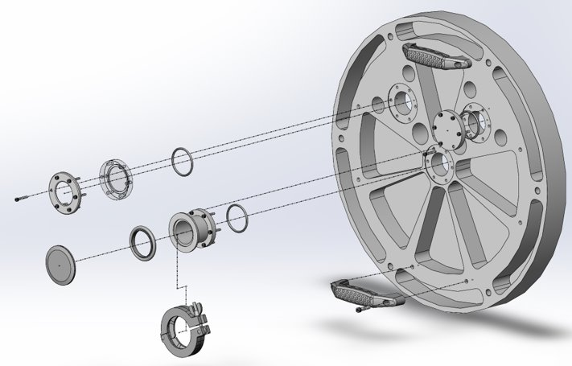
Fig. 27 – Rear seal plate exploded view.

The rear seal plate has the weight reduced to 33 pounds. New optical supports are attached to the rear seal plate for visual check during the vacuum process. The rear seal plate also has handles for carrying by one person.

Design Changes in Second Semester

Design Iteration 1: COVER CHANGES FROM METAL TO BLACKOUT FABRIC WITH VELCRO
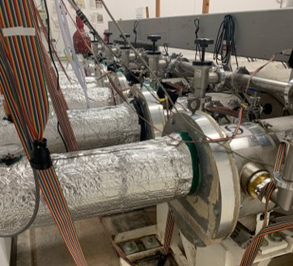
Fig. 26 – Original snoot cover design.

The old light cover design was just an aluminum tube which was also covered by aluminum foil. The technicians had to attach each piece of aluminum foil to have the light cover work, which was time-consuming. With the new light cover using blackout fabric, not only is the assemble time reduced but also easier for the technician to work with. The blackout fabric has Velcro attached to the sides connected to the snoot seal plates. This new design is user friendly and works well with blocking the light.

Challenges Bested
There were many challenges faced within this project, specifically in the second semester upon manufacturing the 3D printed prototype model. Specifically, the manufacturing was halted on 3 separate occasions due to 3D printer severe issues with functionality and hardware. The issues encountered were a fan breakage, a stepper motor binding/overheating, and a glass bed explosion mid-print. The first challenge was when the cooling fan for the 3D printer hot end had 2 blades break off and cause unbalancing of the rotating motion. This caused the printer hot end to heat beyond the desired temperature and cool beyond the desired temperature. Causing a severe print error, called stringing and spaghetti. The printer started to bleed filament out when the hot end increased too much in temperature, and to not extrude filament when the hot end was cooled below the glass transition temperature of the plastic material. This the current seal plate print had to be stopped, a new fan ordered, and printing to be halted until a new fan arrived and was installed. The next issue encountered was the x axis stepper motor binding and hearting up beyond a reasonable function temperature. This caused the printer to not move in the x direction and the print to be scrapped. A new stepper motor was ordered and installed upon delivery. This issue was caused by wear on the printer, due to its 3-year age, and continued use over that time. A new stepper motor installation fixed the issue fully. The final issue encountered in manufacturing was the glass (borosilicate) bed exploding into many fine pieces of glass midprint. This issue was caused by a small crack developed in the bed after removing a large surface area print. The crack was very small upon inspection, and the manufacturing was continued due to the crack not seeming to be an issue. As the bed was heated for the next print and various layers of filament were extruded, stress on the surface was caused, thus increasing the crack size, and causing crack propagation. The crack increase in size was not noticed until it was too late. The print bed was found the next morning shattered into thousands of pieces around the printer enclosure and room which the printer was housed. This issue was remedied first by using a vacuum to clean up all the very sharp glass pieces and ensuring no pieces would cause harm to me or other that would enter the room. A new bed was ordered and printing was halted until the new bed was delivered and installed on the printer. The new bed did not crack or explode, thus the final parts were able to be printed. These challenges added additional stress to the team, due to these happening close to the build status presentations, yet the team overcame these issues by persevering and quickly ordering replacement parts.

Testing

Testing Plan
The P5-NPOI Capstone team has developed a testing plan to verify the scaled prototype functionality of the Customer and Engineering requirements. The testing plan for each specific applicable requirement is shown below. Due to a modification plan made to the capstone, 3 requirements are not able to be tested. This is due to site partner conflicts which have not allowed site access and not allowed the team to access the required hardware for full scale testing.
The following tests will be performed to quantify the system requirements and be compared to the Engineering Requirements Technical Targets to fully verify the design meets the clients’ requirements. The client (Jim Clark) will be talked to obtain approval on these values for final approval of design. These tests are shown in the figures below.

TABLE VI – Customer Needs/Engineering Requirements Associated Tests
Experiment/Test | Relevant Design Requirement
- Front Seal Plate Weight | CR/ER 1
- Rear Seal Plate Weight | CR/ER 1
- Front Seal Plate Deflection | CR/ER 5
- Rear Seal Plate Deflection | CR/ER 5
- Snoot Plate Adjustment | CR/ER 4
- Snoot x/y Adjustment (combined) | CR/ER 4
- Rear Seal Plate Sight Port Count | CR/ER 7
- Allow Laser in & out of Scaled System | ER 8 (NEW, allow light into and out of the system without clipping. Allow full adjustment of parts)

Testing Results
All customer requirements for the testing plan and tests were met or exceeded, the results are shown in the figure below.
TABLE VII – Testing Results
Engineering Requirement | Target | Tolerance | Measured/Calc Value | ER Met? | Client Acceptable?
ER1 – SP Less than 35 pounds | <35 lbs. | ±0.5 lbs. | Front- 34.2 lbs.  Rear- 33.9 lbs. | YES | YES
ER2 – Disassemble in < 60 minutes | < 60 minutes | ±5 min. | N/A | N/A | YES
ER3 – Seals Tank in Vacuum and ATM | Seals Tank | N/A | N/A | N/A | YES
ER4 – X-Y Adjustment of ±0.5” (Scaled @ 35% =0.175”) | ±0.0875” or greater | ±0.010” | -VERTICAL TREE= ±0.3125”  -PISTON STAND=N/A  -VERTICAL PLATE= ±0.125"  -HORIZONTAL PLATE= ±0.125"  -SNOOT PLATE= ±0.10”  -SNOOT PISTON= ±0.125”  * ± Value Given as ½ of Full Range of Adjustment. | YES | YES
ER5 – SP Deformation < 0.01” | <0.010” | ±0.0001” | Front- 0.00373”  Rear- 0.00492” | YES | YES
ER6 – Drift less than 0.001 in/month | < 0.001 in/month | ±N/A | N/A | N/A | N/A
ER7 – 2+ Sight Ports | 2+ Windows | No Tolerance | 1-3 available for use. | YES | YES
ER8 – Unclipped Laser through system | Unclipped Laser Beam | N/A | Unclipped or Clipped upon alignment?

RISK ANALYSIS AND MITIGATION

Potential Failures Identified First Semester
The potential failures defined within the first semester of capstone are shown in Appendix A, and have been defined as critical design failures upon vacuum forces and brittle fracture. As shown in the figure below the key points of critical failure reside in the Seal plate and associated fasteners.
The seal plates hold, in the vacuum state, around 3000 pounds of atmospheric force. This force is fully placed on the lightweight seal plate which has had material removed for the ease of the technicians. Although the lightweight condition is important, the strength of the plate is necessary for keeping the technicians and instrument safe. The critical failure modes of this seal plate are deformations over yield, brittle fracture of the specified seals, and cavitation by corrosion on the seal surfaces. If the deformations in the vacuum state are beyond yield strength the aluminum plates will continuously deform until rupture of the stress concentrators. This would cause catastrophic failure of the system, being the Fast Delay Lines would be unusable, until all components are replaced fully. The seal plate deflection has been defined under engineering requirements as less than 0.010”. This value was decided upon due to the need for a safe seal plate which can handle external loads other than atmospheric pressure. This ensures safety if any accident could occur where the plate will experience greater total force. The seal plate must hold 14.7 psi over an area of 201 in^2, totaling to about 3000 lbf. Any additional force could rupture thin sections, so if the deflection is less than 0.010”, it was determined that the plate is safe for extra load that still allows for the material stress to be under yielding. The verification will happen during the simulations, adding external forces of 100lbf to determine extra loading stress and deformation.

The systems in critical failure show similarity. The main potential failures are the stress, shear and deflection problems. Therefore, there would be no trade-off when trying to mitigate one failure. To prevent the deflection and load applied on the front seal plate, the snoot adjuster/holder would work as the main support, which would carry all the vacuum force and prevent any extra force on z-direction to be applied on the front seal plate. The seal plate needs to be able to prevent deformation during vacuum process and stop the snoot from being sucked inside the tank. Moreover, there would be additional bolt pattern on the tank so that the person who is doing assembly/disassembly process can work easily without worrying about the shear stress effect between the seal plates with the tank.

TABLE VIII – Shortened FMEA
Part # and Functions | Potential Failure Mode | Potential Effect(s) of Failure | Severity (S) | Potential Causes and Mechanism of Failure | Occurrence (O) | Current Design Controls Test | Detection (D) | RPN | Recommended Action
PN# 1, Seal | Force induced deformation | Deformation that exceeds Limit | 10 | Pressure exceeds Strength | 1 | SolidWorks | 1 | 10 | None
PN# 1, Seal | Brittle Fracture | Breaking Seal | 10 | Material doesn’t bend | 1 | SolidWorks | 1 | 10 | None
PN# 1, Seal | Cavitation Corrosion | Deformation that exceeds Limit | 10 | Pressure exceeds Strength | 1 | SolidWorks | 1 | 10 | None
PN# 2, Fasten | Yielding | Deformation | 5 | Pressure exceeds Strength | 3 | SolidWorks | 1 | 15 | None
PN# 2, Fasten | Deformation Wear | Breaking | 8 | Pressure exceeds Strength | 2 | SolidWorks | 1 | 16 | None

Potential Failures Identified This Semester
During the second semester, due to the deliverable modification, the main potential failures within the project are possible breakages of the prototype parts in transit or by attachment methods, and the possible alignment issues with using plastic parts in optical systems. These changes are shown in APPENDIX A, indicated by the yellow highlight.

The possibility of breakage while of the 3D printed prototype is high due to the need for transit and continued assembly and disassembly of the model. Transit is of concern due to the extreme shocks that happen in a vehicle when moving at high speeds. The prototype is made from PLA and is glued together using super glue. The risk of these parts breaking in transit is high because of the shocks endured on the road. Specifically, the parts were packed in cardboard boxes with little padding due to space confinement. The parts bumped into each other and continued to impact each other on turns and potholes. This also can be contributed to the large volume of the models and requirement to print them with little infill. Being the centers are essentially hollow and the walls are the main structure. Although no breakages occurred, careful packing and steady driving was required to ensure no breakages occurred.

Since the key point of the prototype was to allow testing of allowing the laser system to be input and output from the respective metrology and stellar beam holes, plastic was not the ideal prototype material for production. Optical alignments require very rigid fixtures to keep alignments steady as they are used and need to be thermally low expansive to allow for continued use in optical systems. Plastic is known for not being rigid and having a large coefficient of thermal expansion. Thus, the mirror mount fixture had to be made at high infill and be attached to the base in a more rigid fixturing style. Thus 100% infill was used and extra surface area on the bases of the fixtures was essential. Although the bases for all the parts were solid and the mounts were very stiff, optical issues still occurred. These issues were fixed by adding additional surface area on the bottom to allow more support when the adjustment process happened. The issues were worked around, and the project did have a successful laser beam sent into the system, but these came with many struggles and continuous realignment as temperature changed and as the parts were lightly touched.

Although the additional potential failure additions were minimal second semester, the issues of were very apparent and had to be carefully worked around to ensure breakage didn’t occur and the optical system was rigid enough to withstand the processes desired.

Risk Mitigation
[Discuss how your team took the list of potential failures and designed their system to mitigate these failures. Provide design evidence that the major critical failures have a low likelihood of occurring. Also provide discussion regarding any trade-offs in risk mitigation that occurred (i.e. were any risks harder to mitigate when trying to mitigate another? Were any new risks created during the design process?).]

LOOKING FORWARD

Future Testing Procedures
The Navy Precision Optical Interferometer is an observatory which has had state-of-the-art engineering and science since its creation in the early 1990’s. This project is no exception to the site heritage, yet further design iterations may be completed to push this interface system to be more reliable and functionable. The design could be improved by testing the specific seal plate design on the Fast Delay Line Vacuum tanks and testing the snoot adjustability in the vacuum state of the delay lines. The seal plate physical, in vacuum state testing, could benefit the design by verifying the specific deflections and allowing for further iterations to lightweight the plates further. The tests of deformations on the actual system would allow for quantification of the deflections and quantification of leak down of the vacuum tanks. Allowing the NPOI Opto-mechanical group to more accurately be able to predict when vacuum pumping needs to occur and where the seal plates can be further reduced in weight. Testing the snoot adjustment in the vacuum state could also be of value, being slight modification to allow for easier in vacuum adjustment and quantification of the drift of the snoot pipes over long periods of time. The adjustment testing could allow the team to create or modify the design to allow easier adjustments with screws or oil groove marks which allow easier hand adjustments and less external force required to adjust the specific plates. Creating an even more technician friendly design to benefit the Opto-mechanical group. Quantifying the drift of the snoot pipes in the system as the system settles would allow the technicians to more accurately define when adjustments would be required, aside from when the tanks are disassembled. Allowing for a routine alignment process to have time dates for required adjustment before the snoot tubes come out of alignment. This would benefit the NPOI because the alignments would be planned and implemented before misalignment happens and the need is urgent. These future tests would allow the NPOI to become more rounded in its maintenance schedule, allowing for less urgent processes which remove on-sky time for the observatory. Thus, increasing the on-sky time which is crucial for the NPOI to continue collecting valuable science data for the Naval research Laboratory.

Future Iterations
Future iterations of this design for the Fast Delay Line Interface could be a less contaminant style of attaching the snoot adjusters, and further finite element model iterations of the seal plate designs. The current style of attaching the snoot stands is with concrete studs, that require drilling into concrete, causing dust contamination within the sensitive Inner Room (optics room). These contaminants upon being released into the inner room can wreak havoc on the silver coated mirrors, beam splitters, and detectors. Further iteration into a cleaner attachment method would benefit the inner room greatly by removing the need for drilling and releasing the contaminants into the air. This could be possibly adhesively attaching the stand or other non-traditional attachment methods for structural attachment. The iterations of the seal plates could be iterated upon to reduce the weight further, while still adhering to sealing the tanks to vacuum. This could be done further with topological studies, various material changes or additions, and further investigation into the finite element analysis performed within this capstone. The plates being further reduced in weight would greatly improve accessibility for more, less strong technicians, to be able to handle the seal plates with more ease. Reducing the strain further on the technicians. These suggestions could greatly benefit the Navy precision Optical Interferometer Fast Delay Line System and maintenance schedule, allowing for more on-sky time, and less risk involved with the maintenance.

CONCLUSIONS
The P5 – NPOI Capstone team developed a new edition of the Fast Delay Line Vacuum Interface, specifically front and rear seal plates, updated snoot disconnect system, and updated structural snoot adjustable support fixture. The design incorporated lightweight seal plates which can be easily removed with a single technician and allows for the heavy machinery (the gantry crane) to be retired from use in the Fast Delay lines once the designs are implemented. The updated snoot design allows for sectional removal and removing the need for total re-alignment of the input/output beams when a front seal plate needs to be removed. The structural snoot stand fixture allows for axial vacuum force to be removed from the front seal plates and allows for easy adjustment of the snoot tubes for the ability to clip & unclip the respective metrology and stellar beams. The final design meets all customer requirements, if not exceeding the requirements, and the 35% scale prototype proved the concepts of the design with ease.

Reflection
The Navy Precision Optical Interferometer Fast Delay Line Vacuum Interface designed by the P5 – NPOI capstone team implemented technician load relief, removal of heavy machinery, and ensured safety within the NPOI site. The technician load relief was designed around to ensure the final design assisted the Opto-Mechanical group need for less strenuous disassembly and assembly of the Fast Delay Line Interface system. This was accomplished by implementing simple mechanical systems, sound finite element analysis, and designing around the technician desires for the system. The team implemented simple design subsystems which allow for easy understanding of the assembly process, so that the technician did not require vast knowledge of the system to easily be able to disassembly and reassemble the final assembly form. The team used sound finite element analysis to ensure the end structural components were safe in the vacuum environment placed on the inside of the Fast Delay Lines, and ensured the system was rigid enough to seal easily to the moderate vacuum. This was accomplished by implementing worst case scenario boundary conditions and modifying the plates to add strengths were needed, and remove material where stresses were low. Iterating on the seal plates to come to a final form which had very small deflections, ensured safety of all in the vicinity of the Fast Delay Line vacuum system, and was within the weight requirements of the customer needs. The technicians during this design process were constantly thought about and talked to, ensuring the technician was able to use the designs easily. The technicians provided valuable feedback on what current styles of subsystem were not easy to assemble. The team took these very helpful notes and implemented designs which the current technicians considered easy and reliable. Using careful design choices, with feedback and iterations, the P5 – NPOI capstone team was able to create a well-rounded and safe final design. Specifically aimed toward the accessibility and safety of the technician and instrument.

Resource Wishlist
The NPOI capstone team, if able to fully redo the project, would greatly benefit from physical on-site access and the ability to manufacture metal parts to be integrated onto the Fast Delay Line Interface. Physical on-site access would benefit the team in allowing more precision measurement of the current inner room and the ability to test fit full scale prototype parts next to currently implemented systems. The more precision measurements would have allowed the team to have a more precise model of the non-critical parts of the system so that each component could be modified as needed for the specific Fast Delay Line. Specifically, the ability to access FDL #6, where the metrology table optics were of great concern. Allowing the model to show the exact locations of costly beam splitters that the design was implemented to avoid damaging upon disassembly. The ability to manufacture metal parts on-site would have benefited the team greatly, by allowing the machine processes to be learned, and the concepts of surface finishes and O-ring groves to be understood in more depth. The team would have had a much deeper understanding of the specific machine requirements for each call-out on the manufacture drawings, thus allowing the team to understand where the specified callouts would and should not be implemented. Although the client, Jim Clark, was vastly helpful in these regards, physically making the cuts would benefit the team in their careers down the road. Although these Wishlist items would have greatly benefitted the team, the design project at a distance created a better feel for the assurance of part fitment and function. Allowing the team to be more able to make critical judgement calls for when the physical system is not yet fully built or in function.

Project Applicability
The Fast Delay Lines Interface design has prepared each member of the capstone team for a future career by allowing each member to design critical items, verify the item through computational tools, create a manufacturing drawing in which the item will be directly made from, and manufacture through modern additive manufacturing. These steps allow the team to fully understand the engineering process from understanding, design, testing, and manufacture. Allowing each member to be confident in the future when designing and analyzing parts in a system which they have been hired to modify or complete. The final design incorporated parts, subassemblies, and full assemblies (100’s of parts) which allowed each member to determine the best way in which they can design, organize, improve, and implement the systems in which their future careers hold for them. Each member completed the capstone project with a more in-depth design process which they can implement, as they see fit, in their future careers of engineering design, patent law, or systems engineering.

REFERENCES
[1] 'The Importance of Choosing the Correct Material for Vacuum O-Rings and Vacuum Seals'. Apple Rubber. [OnlineAccess]. https://www.applerubber.com/hot-topics-for-engineers/the-importance-of-the-correct-material-for-vacuum-o-rings-and-vacuum-seals/
[2] J.A. Clark III , J. Murphy, L. Ha, J. P. Walton , J. Howard, J. T. Armstrong, G. C. Gilbreath , R. B. Hindsley , and T. A. Pauls. 'Alignment of vacuum feed stations on the Navy Prototype Optical Interferometer'. [OnlineAccess]. https://apps.dtic.mil/sti/pdfs/ADA477246.pdf
[3] 'Vacuum Chambers and Optical Equipment'. Imperial Machine & Tool CO. [OnlineAccess]. https://www.imperialmachine.com/vacuum-chambers
[4] 'The long-stroke MROI vacuum delay lines from concept to generation' [OnlineAccess]. https://www.researchgate.net/publication/237371110_The_long-stroke_MROI_vacuum_delay_lines_from_concept_to_production
[5] “Kurt J. Lesker Company,” www.lesker.com. https://www.lesker.com/index.cfm (accessed Oct. 11, 2022).
[6] “Parker Engineering Your Success Motion Control Technology,” Parker Hannifin Corporation, 2020. https://www.parker.com/portal/site/PARKER/menuitem.b90576e27a4d71ae1bfcc510237ad1ca/?vgnextoid=c38888b5bd16e010VgnVCM1000000308a8c0RCRD&vgnextfmt=EN
[7] “Fittings, Flanges, and Hardware | Ideal Vacuum,” www.idealvac.com. https://www.idealvac.com/Fittings-and-Flanges/ct/2 (accessed Oct. 11, 2022).
[8] “Vacuum Fittings and Flanges,” www.newport.com. https://www.newport.com/c/vacuum-flange-components (accessed Oct. 11, 2022).
[9] “Optical Imaging | Laser Optics | Edmund Optics,” www.edmundoptics.com. https://www.edmundoptics.com/
[10] “Carr,” McMaster. [Online]. Available: https://www.mcmaster.com/. [Accessed: 11-Oct-2022].
[11] “Thorlabs, Inc. - your source for fiber optics, laser diodes, optical instrumentation and polarization measurement & control,” Thorlabs, Inc. - Your Source for Fiber Optics, Laser Diodes, Optical Instrumentation and Polarization Measurement & Control. [Online]. Available: https://www.thorlabs.com/. [Accessed: 11-Oct-2022].
[12] “Aluminum supplier,” Aluminum Supplier | Bar, Sheet, Plate, Tube, Pipe, Shape. [Online]. Available: https://www.industrialmetalsupply.com/Products/Metals/aluminum?gclid=EAIaIQobChMIp7f_rKrZgIV9QetBh3t0QAOEAAYASAAEgKFvPD_BwE. [Accessed: 11-Oct-2022].
[13] “Home,” Alaska Rubber Group. [Online]. Available: https://www.alaskarubbergroup.com/. [Accessed: 11-Oct-2022].
[14] Www.htcvacuum.com 日揚科技股份有限公司 |, “Vacuum components suppliers: Vacuum products manufacturer: Vacuum Chamber Kits - HTC Vacuum,” Vacuum Components Suppliers| Vacuum Products Manufacturer | Vacuum Chamber kits - Htc vacuum. [Online]. Available: https://www.htcvacuum.com/en-global/vacuum-components?gclid=EAIaIQobChMIrKbp4arZ-gIV-BetBh3FDAJXEAAYASAAEgKxi_D_BwE. [Accessed: 11-Oct-2022].
[15] “Socket Head Cap Screws Dimensions & Specs | AFT Fasteners,” www.aftfasteners.com. https://www.aftfasteners.com/socket-cap-screws-dimensions-and-mechanical-properties/ (accessed Oct. 11, 2022).
[16] Light Weight Design Without Compromising Design for Manufacturing. www.custiv.com/blog/systems-level-weight-reduction. Accessed 23 Oct. 2022.
[17] “How to Evaluate Materials – Properties to Consider.” MetalTek, 23 Aug. 2022, www.metaltek.com/blog/how-to-evaluate-materials-properties-to-consider.
[18] Al-Samman, Talal. Material and Process Design for Lightweight Structures. MDPI AG, 2019.
[19] “Aluminum Vacuum Chambers.” Atlas Technologies, 10 May 2021, www.atlasuhv.com/products/vacuum-chambers/aluminum-vacuum-chambers.
[20] “Sealing Options for Aluminum Vacuum Chambers.” Meyer Tool & Mfg., www.mtm-inc.com/sealing-options-for-aluminum-vacuum-chambers1.html. Accessed 23 Oct. 2022.
[21] “Sharon Vacuum Custom Chamber - Vacuum Systems.” BMI Surplus, 14 Sept. 2021, bmisurplus.com/product/sharon-vacuum-custom-chamber.
[22] Apex Vacuum. “Sharon Vacuum Chambers.” Apex Vacuum, 12 Aug. 2020, apexvacuum.com/sharon-vacuum-chambers.
[23] “Vacuum Viewports ” Htc Vacuum, www.htcvacuum.com/en-global/vacuum-components/vacuum-viewport/sapphire-viewport. Accessed 23 Oct. 2022.
[24] Flexible Pipe Bellows | McMaster-Carr. www.mcmaster.com/flexible-pipe-bellows. Accessed 23 Oct. 2022.
[25] Components, M. “Metal Bellows.” MW Components, 18 Aug. 2022, www.mwcomponents.com/metal-bellows.
[26] “---.” Meyer Tool & Mfg., www.mtm-inc.com/sealing-options-for-aluminum-vacuum-chambers1.html. Accessed 23 Oct. 2022.
[27] LJ Star Incorporated. “Sight Glasses, Windows, and View Ports | Find Your Perfect Model.” LJ Star, 19 Aug. 2022, www.ljstar.com/product-lines/sight-glasses.

APPENDICES

Appendix A: FMEA
TABLE A.I – FMEA Summary
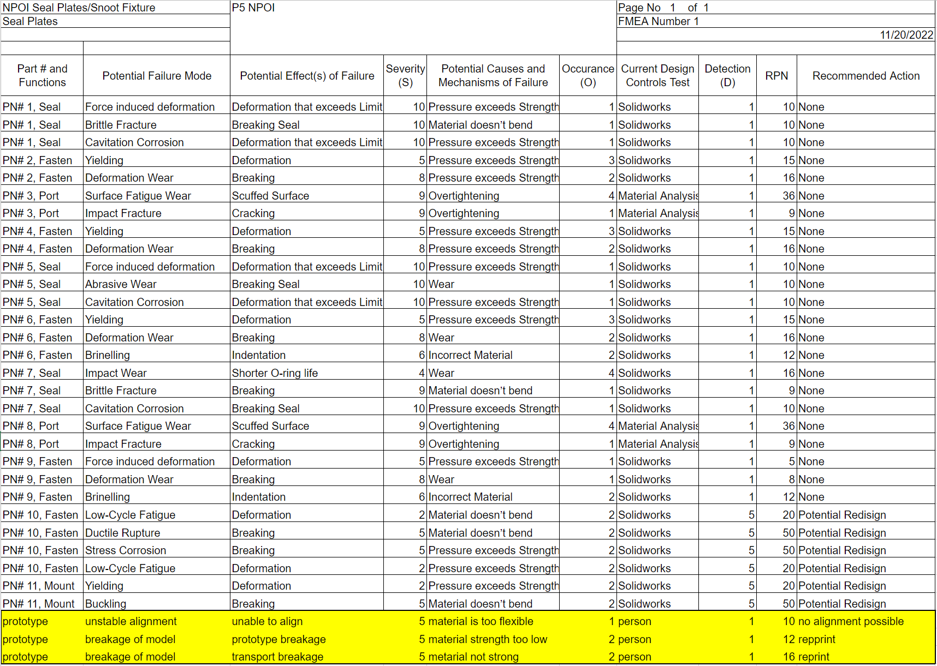

Appendix B: BOM and Budget
TABLE B.I– BOM
